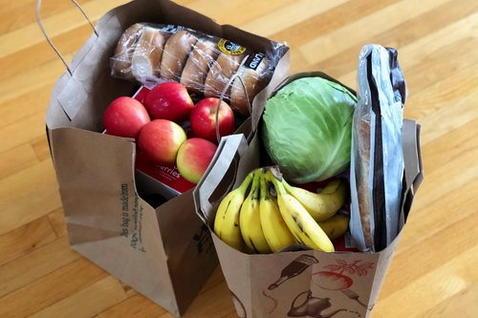  - Planner’s Plate  Food First NL: Current Projects  Sarah Crocker, Program Coordinator, Food First NL  Sarah Crocker, Program Coordinator at Food First NL, presents on the St. John's Food Assessment, bridging the gap between community engagement and municipal action. This approach shapes the response to critical food system issues, inspiring local action on transportation, enterprise, and affordability, including innovative initiatives such as "Food on the Move".  Please join the meeting from your computer, tablet or smartphone.  https://meet.goto.com/201293701  You can also dial in using your phone.  Access Code: 201-293-701  Canada: +1 (647) 497-9391 | Food First NL  ____  Wednesday January 11, 2023 at 12:30 pm (NL Time)  ____  No registration required.  ____  Visit  www.altanticplanners.org  for more information  ____  Newfoundland and Labrador Association of Professional Planners

